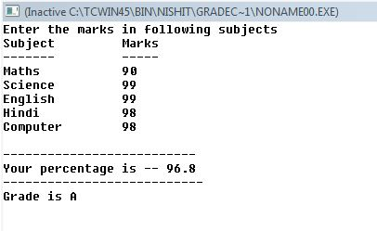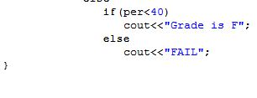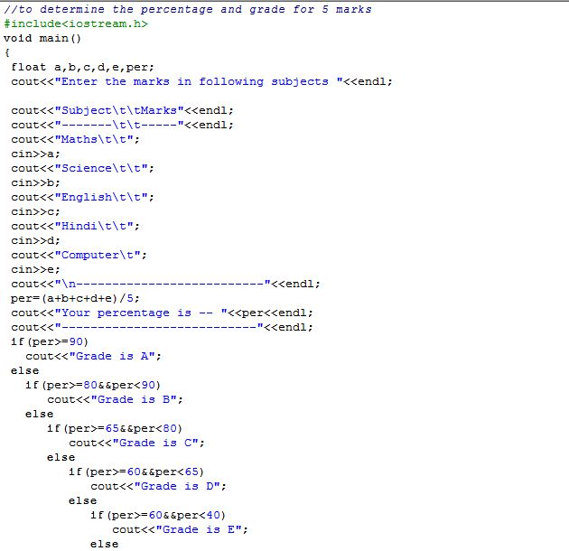

**OUTPUT**

[Type a quote from the document or the summary of an interesting point. You can position the text box anywhere in the document. Use the Text Box Tools tab to change the formatting of the pull quote text box.]